



Reporting
Settlement Reports

Contents
Settlements (Payroll) Reports 3
P010 – Unrated Pay Trips 3
P020 – Unpaid Driver Trips 4
P030 - Pay Period Pay Sheets 5
P031-482- Pay Detail Export for Auditing 6
P040 – Pay Period Post Batch 7
P050 – Trips Missing Paperwork 8
P052 – Split Trips with Paperwork 9
P060 – Trade Payables Pay Period Post Batch 10
P070 - Driver Pay Review 11
P080 - Driver Pay Summary by Pay Period 12
P085 – Company Owner Payroll 13
P090CR – Driver and Truck List with Compliance Dates 14
P100 – Deduction Summary by Date Range 15
P101- Deduction Summary by Date Range by Truck 16
P110 – Unposted Payables 17
P115 – Accrued Payables 18
P120 – Deduction Summary for One Deduction Type 19
P120-9144 – Deduction Summary for one Deduction Type 20
P121 – Outstanding Deduction Summary for One Deduction Type 21
P140 – Unpaid Drivers and Carriers 22
P150 – Amortized Deductions by Driver 23
P170 – Driver Pay Tables 24
P180 – Split Load Details 25
P200 – Deadhead Moves Only with Driver Pay 26
P300 – Owner Pay Summary by Date Range 27
P400 – Comdata Transaction Report 28
P401 – Pending Advance Deductions 29
P405 – Comdata Transaction Report Linked to Deductions 30

Settlements (Payroll) Reports
Payroll reports are available in the Settlements main menu item under the “Settlement Reports” sub menu item.

P010 – Unrated Pay Trips
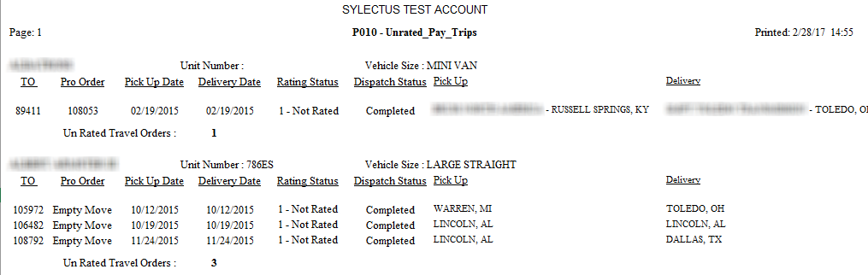
Purpose: Un-Rated Trips are trips that have been completed in the Sylectus system, but they have not been given an initial rating in the Settlements system. You can see these trips online under “Settlements” then “Pay Trips” with status of “Not Rated”. This report will give you the complete summary, by driver, of un-rated trips.
Parameters: There are no parameters for this report.
Resulting Report: The report will show the following results:
- Travel Order Number
- Pro or Order Number
- Date of First Pick Up
- Date of Last Delivery
- Rating Status – this will be either 0 (needs to be checked) or 1 (not rated)
- Dispatch Status – Should always be “COMPLETED”
- Pick Up – Shows the customer name, city, state and zip of the first pick up.
- Delivery – Shows the customer name, city, state and zip of the last delivery.

Sub Totals and Totals: This report is sub-totaled by DRIVER or Preferred Carrier and gives a trip count.

P020 – Unpaid Driver Trips
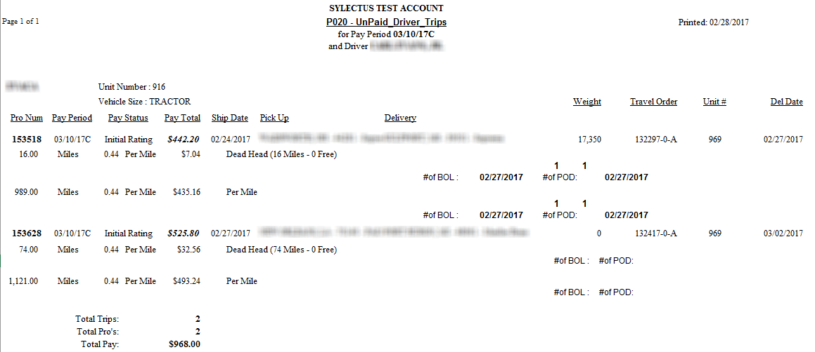
Purpose: Un-Paid Driver Trips are trips that have been rated, but NOT yet paid to the driver. You can see these trips online under “Settlements” then “Pay Trips” with status of “Rated”. Could also include TO’s which are still onRoute.
Parameters: When you run this report you have one parameter:
    - Pay Periods to Print
    - Show Details

Resulting Report: The report will show the following results:
- Pro / Pay Period Name
- Pay Status
- Pay Total – Total Pay for the Trip.
- Ship Date - Date of First Pick Up
- Pick Up – Shows the customer name, city, state and zip of the first pick up.
- Delivery – Shows the customer name, city, state and zip of the last delivery.
- Weight – Total weight for the Pro.
- Travel Order – Travel Order Pay Number
- Pay Charge Type – (Quantity x Rate = total pay)
- Paperwork Check In Dates – POD and BOL

Sub Totals and Totals: This report is sub-totaled by DRIVER or Preferred Carrier. It will show the total trips (Travel Orders), total Pro’s (Orders) and Total Revenue.

P030 - Pay Period Pay Sheets
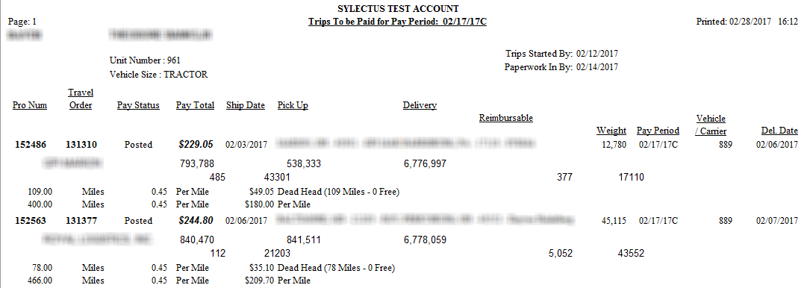
Purpose: This report includes trips that have been completed in the Sylectus system, rated in the Settlements system, and tagged as belonging to a certain Pay Period. They may or may not be ready to pay to the driver, but are ELIGIBLE to pay for the current pay period.
Parameters: When you run this report you have two parameters:
    - Pay Period Name
    - Driver ID – ALL or a certain specific driver

Resulting Report: The report will show the following results:
- Pro Number / Travel Order Number
- Pay Status – This will be any rated trip for the selected pay period
- Pay Total – Total Pay for the Trip
- Ship Date
- Pick Up – Shows the customer name, city, state and zip of the first pick up
- Delivery – Shows the customer name, city, state and zip of the last delivery
- Reimbursable
- Weight – Total weight for the Pro
- Pay Period (as you set up in the Pay Periods table)
- Pay Charge Type – (Quantity x Rate = total pay)

Sub Totals and Totals: This report is sub-totaled by DRIVER or Preferred Carrier. It will show the total trips (Travel Orders), total Pro’s (Orders) and Total Revenue.

P031-482- Pay Detail Export for Auditing
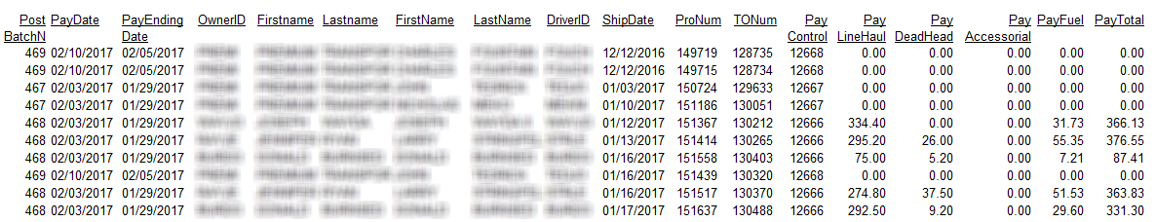
Purpose: This report will provide a detailed summary of pay detail that can be exported and used for auditing purposes.
Parameters: When you run this report you have two parameters:
- Start Date
- End Date

Resulting Report: The report will show the following results:
- Post Batch Number
- Pay Date
- Pay Ending Date
- Owner ID
- First and Last Name
- Driver ID
- First and Last Name
- Ship Date
- Pro and TO number
- Pay Control
- Pay Deadhead
- Pay Accessorial
- Pay Fuel
- Total Pay

Sub Totals and Totals: None

P040 – Pay Period Post Batch
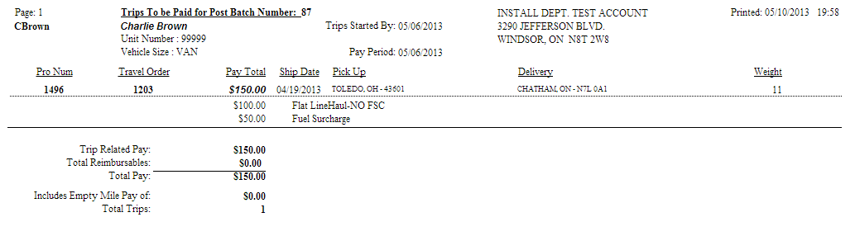
Purpose: Trips by Pay Post Batch Number are trips that have been completed in Sylectus, rated in the Settlements system, and posted for payment. This report will give you the complete summary, by driver, of paid trips and it will show the key pay dates (Paperwork checked in by and Trips started by dates).
Parameters: When you run this report you have five parameters:
    - Pay Post Batch Number
    - Include Customer Names
    - Include Calculations
    - Driver ID
    - Show Paperwork check in date

Resulting Report: The report will show the following results:
- Pro number / Travel Order number
- Pay Total – Total Pay for the Trip
- Ship Date
- Pick Up – Shows the customer name, city, state and zip of the first pick up. The customer name is only shown IF Include Customers Names = Y.
- Delivery – Shows the customer name, city, state and zip of the last delivery. The customer name is only shown IF Include Customers Names = Y.
- Weight – Total weight for the Pro
- Pay Type
- Pay Amount – the rate to pay the driver

Sub Totals and Totals: This report sub-totals and grand totals by Driver or Preferred Carrier. It will show a total trip count, total empty mile pay, and total related pay. The report grand totals in the same way.

P050 – Trips Missing Paperwork
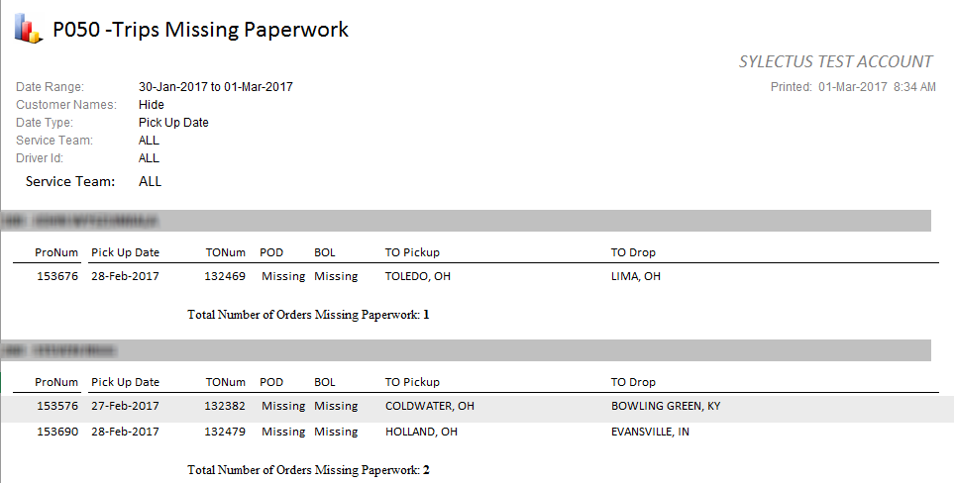
Purpose: Typically, you cannot invoice your customers until you have all the paperwork in the system. This report will identify which drivers need to submit paperwork, it shows a list of all trips missing paperwork by truck and driver. This report has 3 sub reports, they are:
RPT 1: Brokered Loads Within Date Range – Lists Carriers and the number of BROKERED LOADS performed in the date range provided, based on Pick Up Date.
RPT 2: NON-Brokered Loads Within Date Range – Lists Carriers and the number of BROKERED LOADS performed in the date range provided, based on Pick Up Date.
RPT 3: All Loads Within the Date Range – Lists Drivers/Carriers and the number of BROKERED LOADS performed in the date range provided, based on Pick Up Date.
Parameters: This report has six parameters:
    - Start Date – The date to begin the date range
    - End Date – The date to end the date range
    - Hide Customer Names
    - Date Type – Pick Up Date / Delivery Date
    - Driver – ALL or pick a specific driver
    - Service Team – ALL or pick a specific team

Resulting Report: The report will show the following results:
- Pro Number / Driver Name / Carrier Name
- TO number / POD or BOL missing
- Pick Up Date / Pick Up Location / Drop Location
- Trip Count

Sub Totals and Totals: This report is sub-totaled by DRIVER or Preferred Carrier. It will show the trips missing paperwork.

P052 – Split Trips with Paperwork
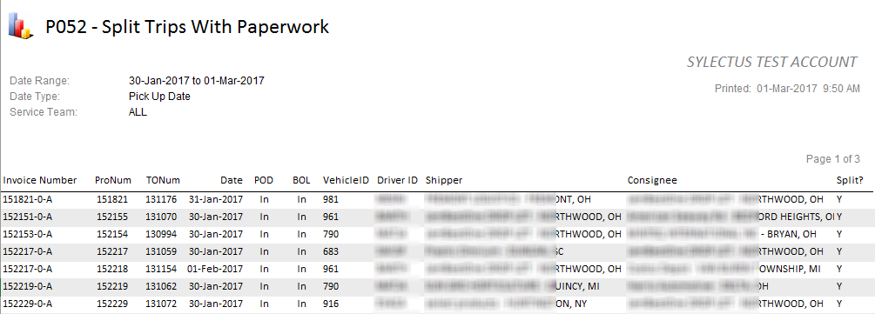
Purpose: This report displays all split trips that included paperwork within a date range.
Parameters: This report has four parameters:
- Start Date – Date to begin the date range
- End Date – Date to end the date range
- Select Date Type – Pick up date / Delivery date / Posted date
- Select Service Team – All or a specfic service team

Resulting Report: The report will show the following:
- Invoice number / order number / travel order number
- Date – as choosen in the parameters
- Proof of Delivery and Bill of Lading
- Vehicle and Driver ID
- Shipper and consignee information

Sub Totals and Totals: This report will show a total count of split orders with paperwork for the chosen date range.

P060 – Trade Payables Pay Period Post Batch
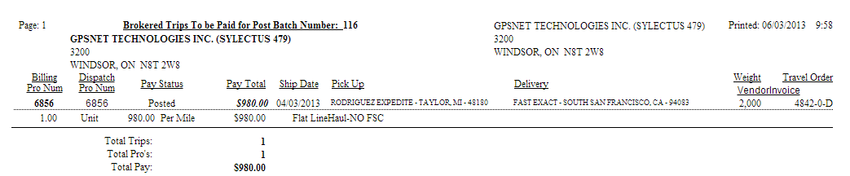
Purpose: Trips by Pay Post Batch Number are trips that have been completed in the Sylectus system, rated in the Settlements system, and posted for payment. This report will give you the complete summary, by BROKERED COMPANY, of paid trips. When you print the report, there is one page per Preferred Carrier or Brokered Company.
Parameters: When you run this report you have one parameter:
    - Pay Post Batch Number

Resulting Report: The report will show the following results:
- Pro or Order Number
- Pay Period (as you set up in the Pay Periods table)
- Pay Status – This will be any rated trip for the selected pay period.
- Pay Total – Total Pay for the Trip.
- Ship Date - Date of First Pick Up
- Pick Up – Shows the customer name, city, state and zip of the first pick up.
- Delivery – Shows the customer name, city, state and zip of the last delivery.
- Weight – Total weight for the Pro.
- Travel Order – Travel Order Pay Number

For EACH PRO, the report will show the pay detail lines. The Pay detail lines will show the following:
  - Pay Quantity (i.e. 345 miles or $120.00 revenue, etc.)
  - Pay Quantity Unit of Measure.
  - Pay Rate (i.e. $1.25 per mile or 0.60 percent)
  - Pay Rate Unit of Measure
  - Pay Amount – the rate to pay the driver.
  - Pay Description – a short description of what the pay amount is all about.

Sub Totals and Totals: This report is sub-totaled by Preferred Carrier. It will show the total trips (Travel Orders), total Pro’s (Orders) and Total Revenue.

P070 - Driver Pay Review
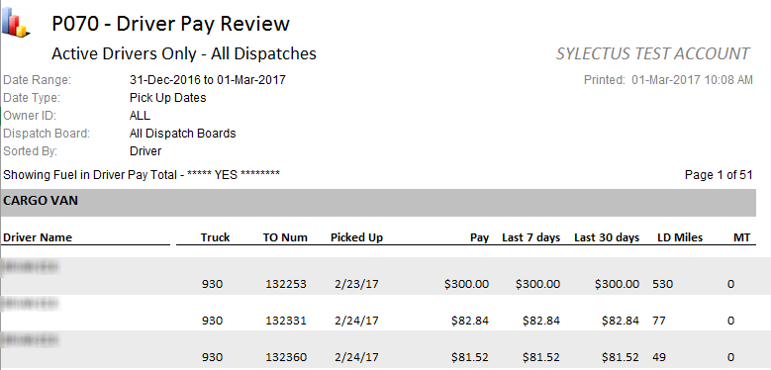
Purpose: This report summarizes driver pay information by date range and sorts and sub totals the results of this information by driver. It is a good report to analyze which drivers need additional revenue based on recent pay information.
Parameters: When you run this report you have 12 parameters.
- Start Date – The starting date for the search
- End Date – The ending date for the search
- Details – show one line per invoice / show summary
- Dispatch Type –All Dispatches / My Trucks / Brokered Loads
- Driver Page Break
- Date Type – Pick Up date / Delivery date
- Sort By – Driver or Carrier / Owner then Driver or Carrier
– Vehicle Class then Driver or Carrier
- Driver Name – All or a specific driver
- Dispatch Board
- Show Fuel in Pay Total
- Enter Owner ID – ALL or enter a specific ID
- Driver Status – ALL / Retired / Active

Resulting Report: The report will show the following results:
- Driver Name / Truck number
- Travel Order Number
- Date Travel Order started
- Pay Total to Driver
- Pay amount in last 7 days (current date – 7)
- Pay amount in last 30 days (current date – 30)
- Loaded Miles / Empty Miles

Sub Totals and Totals: This report is sub totaled by driver and grand totals with averages by the mile and by the travel order. It also gives total pay and miles for their respective columns.

P080 - Driver Pay Summary by Pay Period
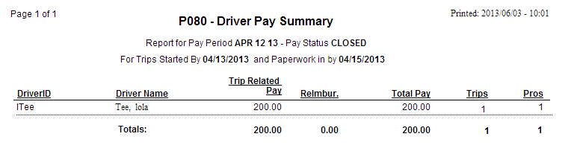
Purpose: This report summarizes driver pay information Summarized by Pay Period and sorts and totals the results of this information by Driver ID. It is a good report to analyze which drivers need additional revenue based on recent pay information, and the number of trips they have been on.
Parameters: When you run this report you have four parameters. Your options are as follows:
- Pay Period – The pay period for the search

Resulting Report: The report will show the following results:
- Driver ID
- Driver Name
- Trip Related Pay
- Reimbursable
- Pay Total to Driver
- Trips the Driver has made
- Pros

Sub Totals and Totals: This report is totaled by Driver and then gives a grand total at the bottom. These are calculated for the Pay period in question.

P085 – Company Owner Payroll
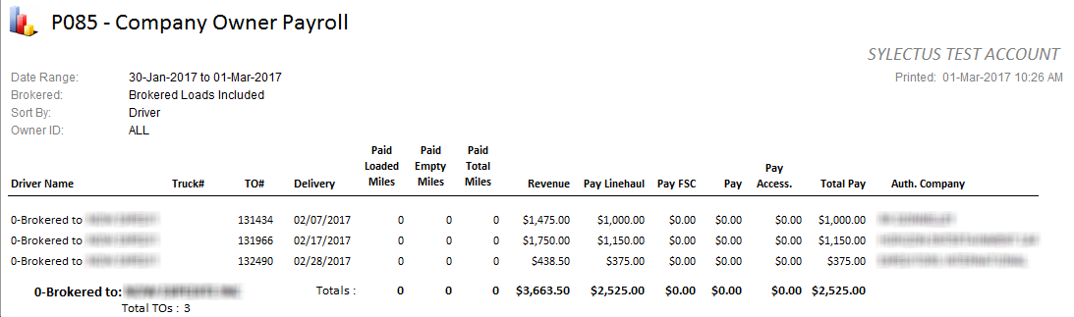
Purpose: This report shows revenue and expense sorted by driver or carrier.
NOTE: This report WILL NOT match GROSS MARGIN reports, other than B108-1, because we ALLOCATE revenue to drivers when the load is cross docked. The allocation of revenue is based on the "Percent of the Load" that the driver performs. So it is QUITE POSSIBLE that when more than one driver / truck does a load, that the allocated amount exceeds 100 percent.
Parameters: When you run this report you have four parameters. Your options are as follows:
- Start Date
- End Date
- Details
- Sort By – Driver / Truck / Truck Class / Owner / Trailer
- Show Brokered Loads?
- Owner ID – ALL or a specific ID

Resulting Report: The report will show the following results:
- Driver ID / Carrier
- Driver Name
- TO number / Delivery Date
- Revenue
- Trip Related Pay
- Total Pay
- Authorization Company for that order

Sub Totals and Totals: This report is totaled by driver and then gives a grand total at the bottom.

P090CR – Driver and Truck List with Compliance Dates
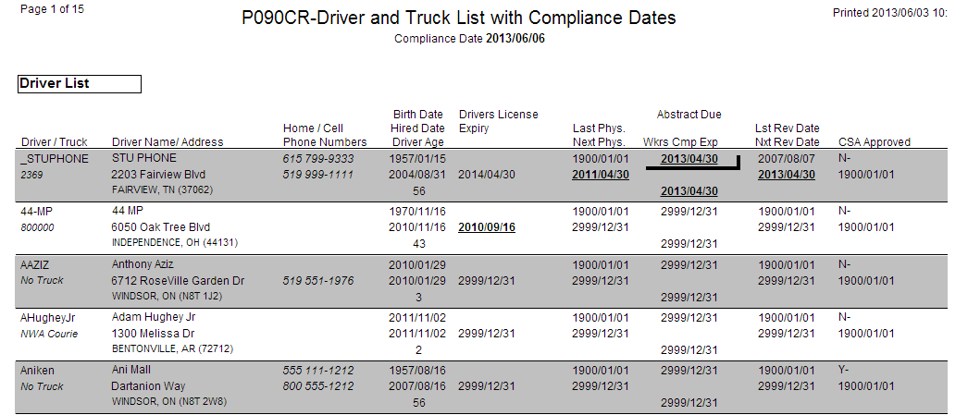
Purpose: This report lists Drivers and Trucks with their compliance dates.
Parameters: There are two parameters for this report:
- Compliance Date
- Show Social Security Number

Resulting Report: The report will show the following results for each driver and truck:
- Driver and Truck ID
- Driver Name and Address
- Home and Cell phone numbers
- Birth Date, Hired Date and Driver Age
- Drivers License Expiration Date and Social Security Number
- Last and Next Physical
- Abstract Due and Wkrs Cmp Exp
- Last and Next Review Date
- CSA Approved

Sub Totals and Totals: Total driver count / Total truck count.

P100 – Deduction Summary by Date Range
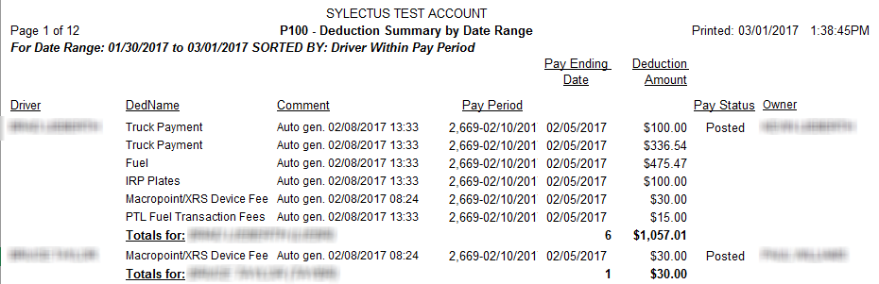
Purpose: This report shows all types of pay deductions for drivers within a date range.
Parameters: When you run this report, you have three parameters:
- Start Date – Date to start the date range
- End Date – Date to end the date range
- Sort option – Driver within pay period / Pay period within Driver
– Deduction type within pay period / Pay period within Deduction Type
– Owner within pay period / Pay period within owner
– Driver within deduction Type / Deduction type within Driver
– Driver ID Within Pay Period
- Driver ID – ALL or enter a valid Driver ID
- Show Details?

Resulting Report: For each deduction, the following information will be shown:
- Driver name
- Deduction Name
- Comment
- Pay period
- Pay ending date
- Deduction amount
- Pay status
- Owner

Sub Totals and Totals: This report shows subtotals by driver, owner, pay period, or deduction type. The report also shows grand totals for all deductions in the date range.

P101- Deduction Summary by Date Range by Truck
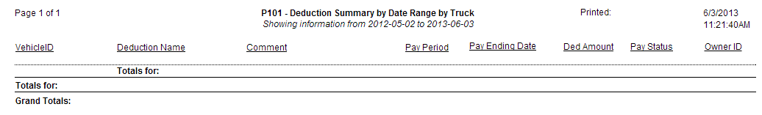
Purpose: This report displays information regarding deductions summaries by date range for a specific truck.
Parameters: There are five parameters for this report:
- Start Date – Date to start date range
- End Date – Date to end date range
- Show Details? – Yes show details or No don’t show details
- Sort option – Truck within pay period / Pay period within Truck
– Deduction type within pay period / Pay period within Deduction Type
– Owner within pay period / Pay period within owner
– Truck within deduction Type / Deduction type within Truck
- Vehicle ID – Select a vehicle ID or run the report for all vehicles

Resulting Report: This report will result in the following:
- Vehicle and Owner ID
- Deduction name and comments
- Pay period and pay ending date
- Deduction amount and pay status

Sub Totals and Totals: The report will show a sub total of deductions per truck and then a grand total of all the deductions for each truck.

P110 – Unposted Payables
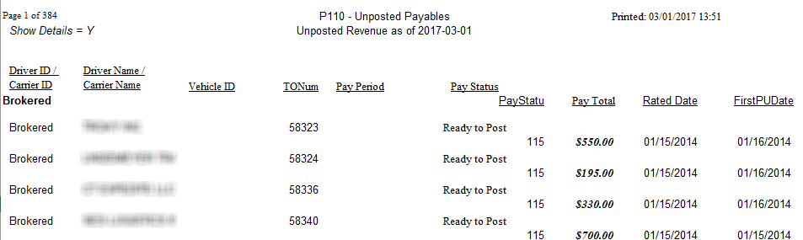
Purpose: This report shows all revenue that has not been posted on or before a user specified date.
Parameters: When you run this report, you have two parameters:
- As of date – all payables unposted ON or BEFORE this date
- Show details

Resulting Report: For all unposted revenue, the following information will be shown:
- Driver ID
- Driver name
- Vehicle ID
- Pay period
- Pay status
- Pay total
- Rated date
- First pick up date

Sub Totals and Totals: This report shows subtotals by driver/carrier and grand totals for all unposted payables.

P115 – Accrued Payables
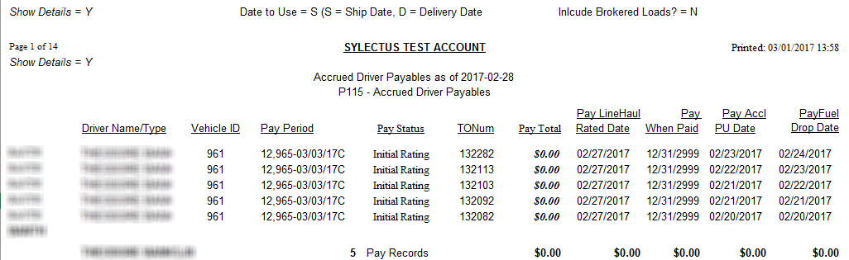

Purpose: This report shows all payables that were NOT posted through to the accounting software “as of” the DATE provided by the user running the report.
This report tries to identify all the PAY RECORDS that were NOT POSTED on (or before) the “as of” date, and were POSTED after the “as of” date. For example, assume the “as of date” is February 1. If the load (picks up / delivers) ON OR BEFORE February 1, but gets posted AFTER February 1, 2006, then the expense is recognized as occurring “on or before the as of date”, but posted after the “as of date” (even if the pay record shows as “posted” on the date the report is run). The purpose of this report is to allow companies to ACCRUE expenses based on the status of the pay record AS OF a certain date. It is important that payroll staff POST the invoice to their accounting system on the SAME DATE they create the POST BATCH for other carriers or close the Pay Period.
Parameters: When you run this report you have four parameters.
- As of Date – The report will include data ON or BEFORE the as of date
- Details – show one line per pay record / show summary
- Include Brokered
- Date to use – Ship date / Delivery date

Resulting Report: The report will show the following results:
- Driver ID or Carrier ID
- Driver Name or Carrier Name
- Vehicle ID
- Pay Period Name / Pay Status
- Travel Order Number
- Pay Total
- Rated Date Used (either the “Ship Date” or “Delivery Date”)
- When Paid Date (date carrier / driver was actually paid)
- Pick Up Date
- Delivery Date

Sub Totals and Totals: This report is sub totaled by driver/carrier. It will show pay record counts and expense. This report has a grand total showing pay record counts and expense.

P120 – Deduction Summary for One Deduction Type
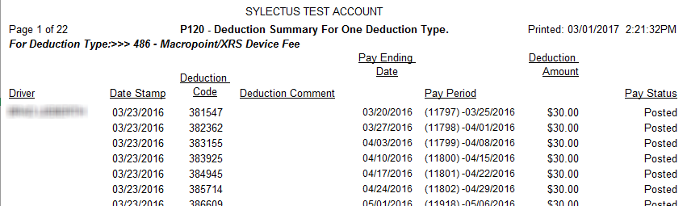
Purpose: This report shows driver pay deductions filtered to only one desired deduction type.
Parameters: When you run this report, you have one parameter:
- Deduction type – choose which type to show

Resulting Report: For each deduction, the following information will be shown:
- Driver name
- Date stamp
- Deduction code
- Deduction comment
- Pay ending date
- Pay period
- Deduction amount
- Pay status

Sub Totals and Totals: This report shows subtotals by driver and grand totals for all deductions.

P120-9144 – Deduction Summary for one Deduction Type
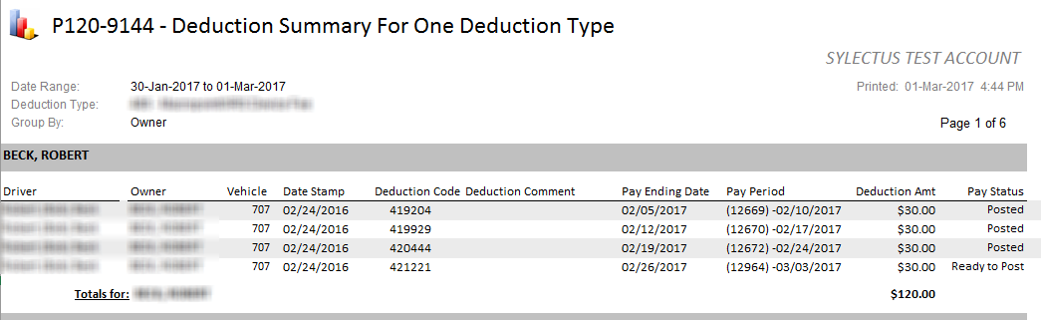
Purpose: The purpose of this report is to break down each deduction type by driver or owner.
Parameters: There are 4 parameters to this report.
- Deduction Type
- Start Date
- End Date
- Group By (Owner, Driver)

Resulting Report:
- Driver, Owner & Vehicle ID
- Date Stamp
- Deduction Code and Comment
- Pay Ending Date
- Pay Period
- Deduction Amount
- The Pay Status

Sub Totals and Totals: This report sub totals all deductions based on either Owner or Driver (depending what you have selected) and then shows a grand total of the deduction amounts.

P121 – Outstanding Deduction Summary for One Deduction Type
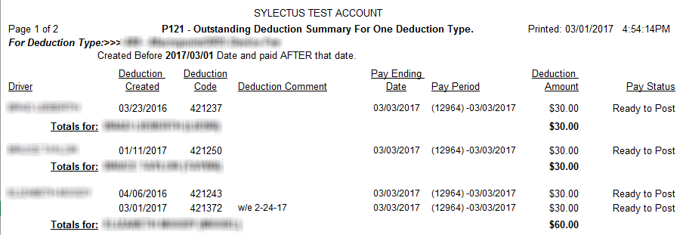
Purpose: This report shows any deduction header record where the driver was not paid until after a user specified cutoff date. This report looks at any PayDedSched (Deduction Header) record where the deduction was CREATED prior to a cutoff date (usually an accounting period end date) and was not PAID to the driver until AFTER that same date. It excludes cancelled Deduction Header records (PayDedSched.PayStatus = 2 AND no PayDedDetail record exists). This report will probably only work for Advance type deductions.
Parameters: When you run this report, you have two parameters:
- Deduction type – Choose a deduction
- Prior to which ending date

Resulting Report: For each outstanding deduction, the following information will be shown:
- Driver name
- Deduction created
- Deduction code
- Deduction comment
- Pay ending date
- Pay period
- Deduction amount
- Pay status

Sub Totals and Totals: This report shows subtotals by driver, as well as a grand total of all outstanding deductions.

P140 – Unpaid Drivers and Carriers
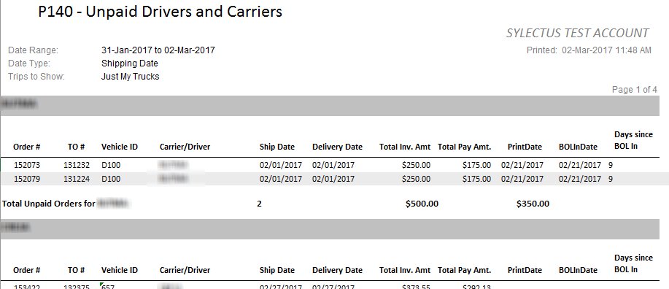
Purpose: This report shows a summary of drivers or carriers who have not yet been paid.
Parameters: There are 4 parameters for this report.
- Trips to Show – Just my Trucks / Brokered Loads Only / All Loads
- Start Date
- End Date
- Date Type – Shipping date / Delivery date

Resulting Report:
- Pro and travel order number
- Vehicle ID
- Carrier/ Driver ID
- Ship and Delivery dates
- Total Invoice amount
- Total Pay Amount
- Print Date
- BOL in Date
- # of Days since BOL was in

Sub Totals and Totals:
This report shows a total by driver/carrier of unpaid trips as well as a grand total of unpaid orders.

P150 – Amortized Deductions by Driver
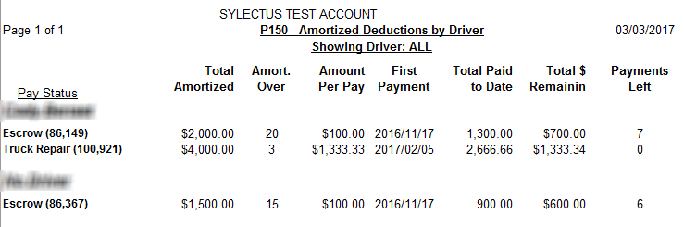
Purpose: This report shows a summary of amortized deductions by driver
Parameters: This report has only 1 parameter.
- Select an individual Driver ID or All Drivers
Resulting Report:
- Driver Name
- Pay Status / Deduction Name
- Total Amortized Amount
- Amortized Over (Length of time)
- Amount Per Pay
- First Payment
- Total Paid to Date
- Total Remaining
- # of Payments Left

Sub Totals and Totals: None

P170 – Driver Pay Tables
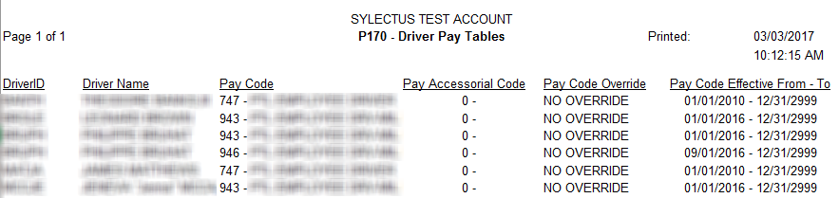
Purpose: This report shows a summary of driver pay tables assigned to each driver.
Parameters: None
Resulting Report:
- Driver ID and Name
- Pay Code
- Pay Accessorial Code
- Pay Code Override
- Effective from and to dates

Sub Totals and Totals: None

P180 – Split Load Details
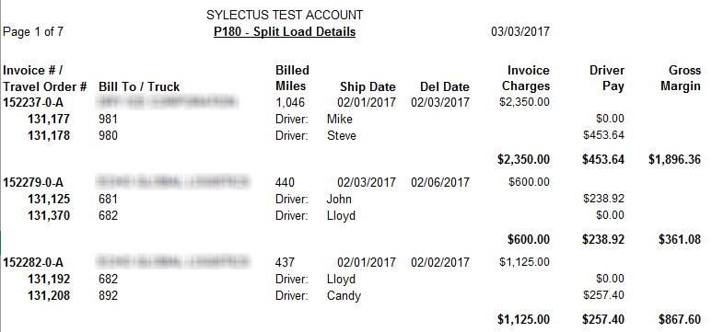
Purpose: This report shows a summary of the split loads for a specified date range in relation to driver pay.
Parameters: This report has 3 parameters.
- Start Date
- End Date
- Select Data Type

Resulting Report:
- Invoice #
- TO number
- Bill To / Truck
- Billed Miles
- Ship and Delivery Date
- Driver Name
- Invoice Charges
- Driver Pay amount
- Gross Margin

Sub Totals and Totals: None

P200 – Deadhead Moves Only with Driver Pay
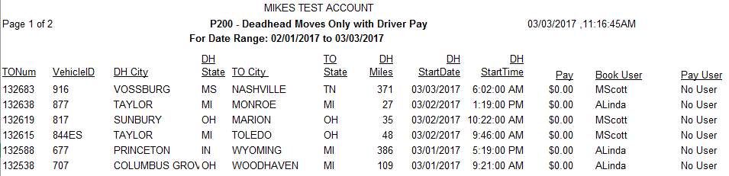
Purpose: This report shows a summary of deadhead moves based on driver pay within a specified date range.
Parameters: There are 2 parameters for this report.
- Start Date
- End Date

Resulting Report:
- Travel Order #
- Vehicle ID
- Deadhead City, State
- To City, State
- # of Miles
- Start Date and Time
- Pay Amount
- Book User
- Pay User

Sub Totals and Totals: This report shows a total number of orders, deadhead miles and deadhead pay amounts.

P300 – Owner Pay Summary by Date Range
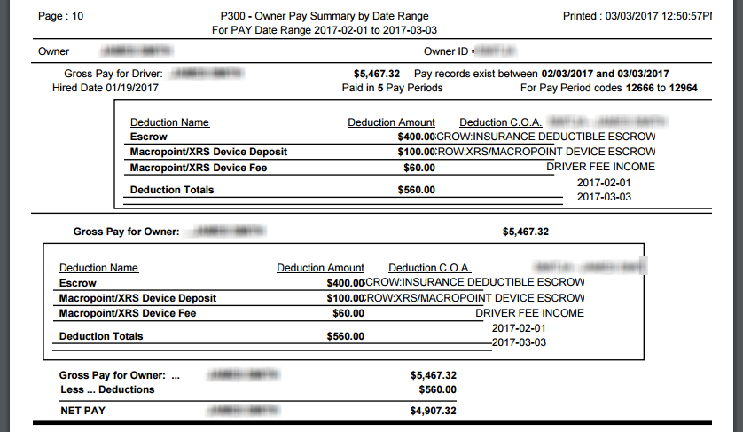
Purpose: This report displays vehicle owner pay information for a user specified date range. Best viewed in PDF, a page for each driver.
Parameters: When you run this report you have two parameters:
- Start Date – Date to start the date range
- End Date – Date to end the date range

Resulting Report: For each owner, the following information is shown:
- Pay Period Code to Pay Period Code
- Gross pay for driver (includes deduction information, if any)
- Deduction Name and Amount
- Gross pay for owner (includes deduction information, if any)
- Net pay

Sub Totals and Totals: This report shows deduction subtotals by driver and owner, as well as net pay totals by owner.

P400 – Comdata Transaction Report
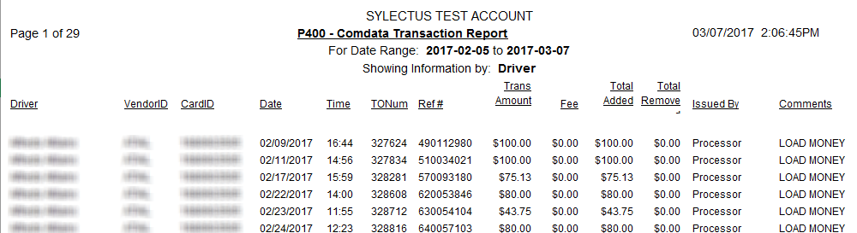
Purpose: This report displays transaction information from Comdata for a specific date range.
Parameters: When you run this report you will have 3 parameters:
- Start Date – Date to start the date range
- End Date – Date to end the date range
- Sort By – Driver / Owner / Vehicle / Card ID, or No sort(Date/Time)

Resulting Report: The following information is shown:
- Driver Name / Vendor ID
- Card ID
- Date and time it was added
- TO number
- Reference Number
- Amount of money added
- Fees
- Issed By – Who added the money to the card

Subtotals and Totals: This report sub totals and totals the amount of money added to specific card IDs, and gives a transaction count.

P401 – Pending Advance Deductions
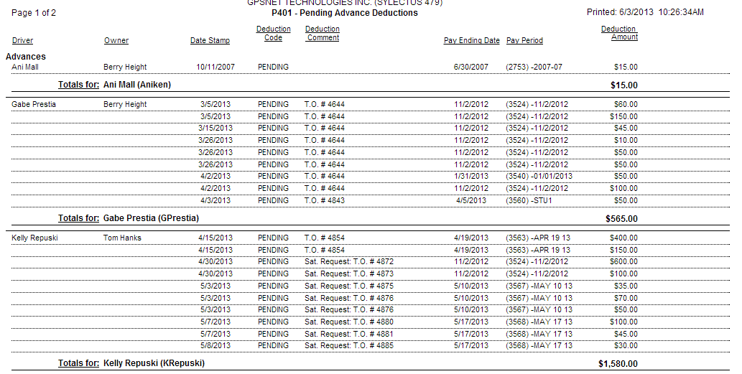
Purpose: This report displays information about pending advances and deductions
Parameters: When you run this report you will have two parameters:
- Sort By – Sort by Driver, Owner or Date
- Deduction Type – Select the Deduction (created from “Deduction Types”)
- Start Date
- End Date

Resulting Report: The following information is shown:

- Driver and Owner Name
- Deduction code and comment
- Pay ending date and pay period
- Deduction amount

Subtotals and Totals: The resulting report will show the total amount of advances per driver or owner.

P405 – Comdata Transaction Report Linked to Deductions
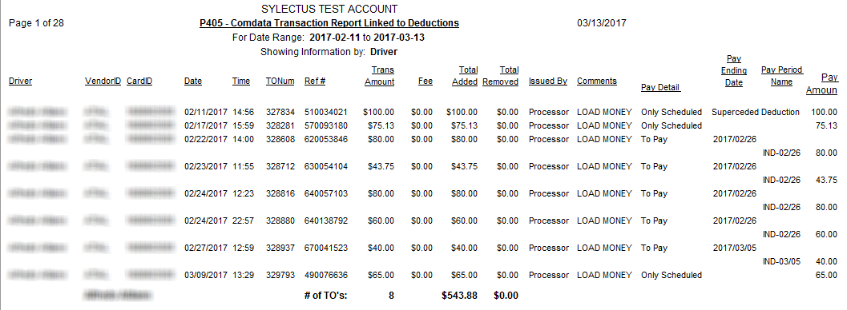
Purpose: This report displays transaction information from Comdata for a specific date range while linking the information to deductions.
Parameters: When you run this report you will have 3 parameters:
- Start Date – Date to start the date range
- End Date – Date to end the date range
- Sort By – Driver / Owner / Vehicle / Card Id / No sort(Date/Time)

Resulting Report: The report will show the following:
- Driver Name / Vendor ID
- Card ID
- Date and time it was added
- TO number
- Reference Number
- Amount of money added
- Fees
- Issed By – Who added the money to the card
- Pay Period Name
- Deduction Amount

Subtotals and Totals: The resulting report will show the total amount of advances per driver or owner.

